FOUCAULT UPDATES
State Link 3
Utilitarianism Link 4
A2 : Perm 5
Individuals Link 6
Interests Link 7
A2 : The State 8
Impossible to Resist 9
Impossible to Resist 10

State Link
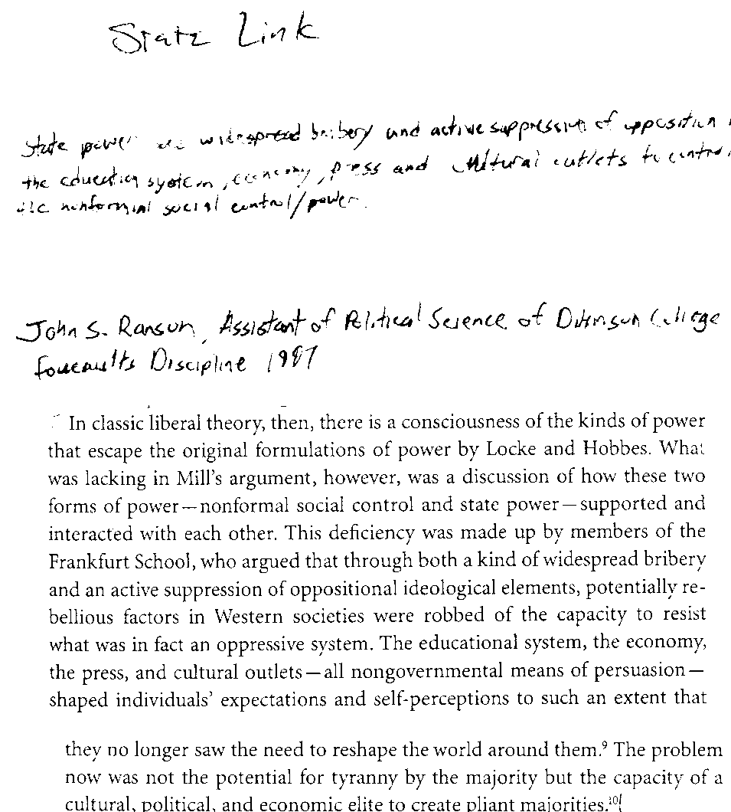

Utilitarianism Link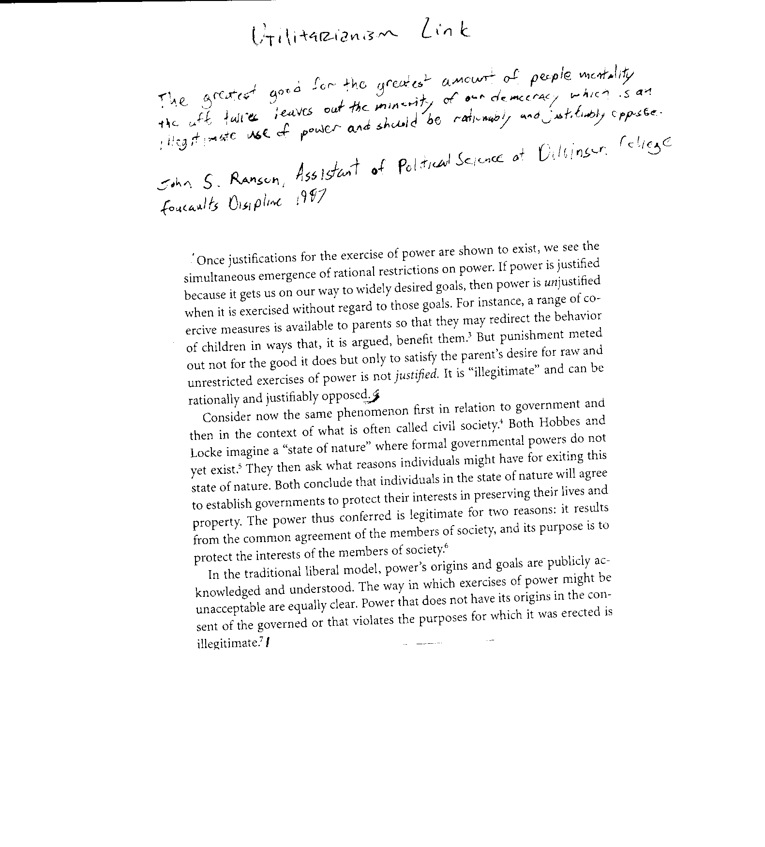

A2 : Perm
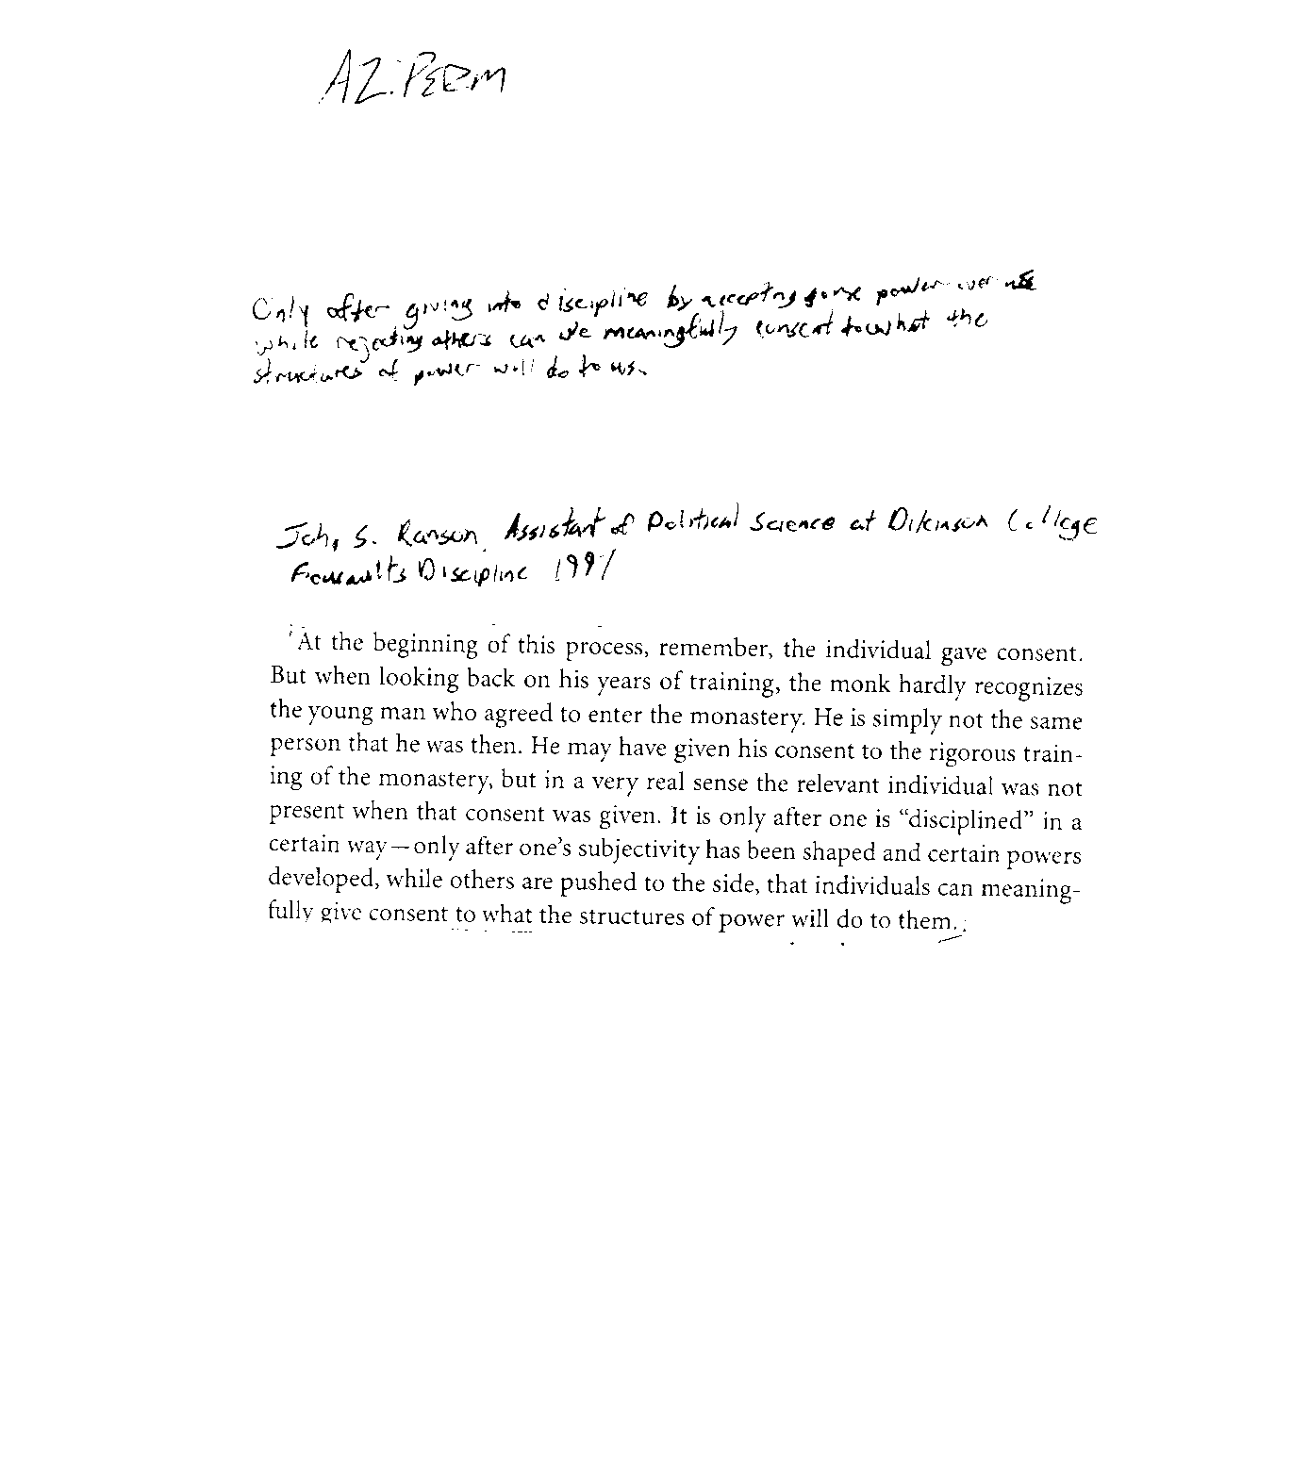

Individuals Link
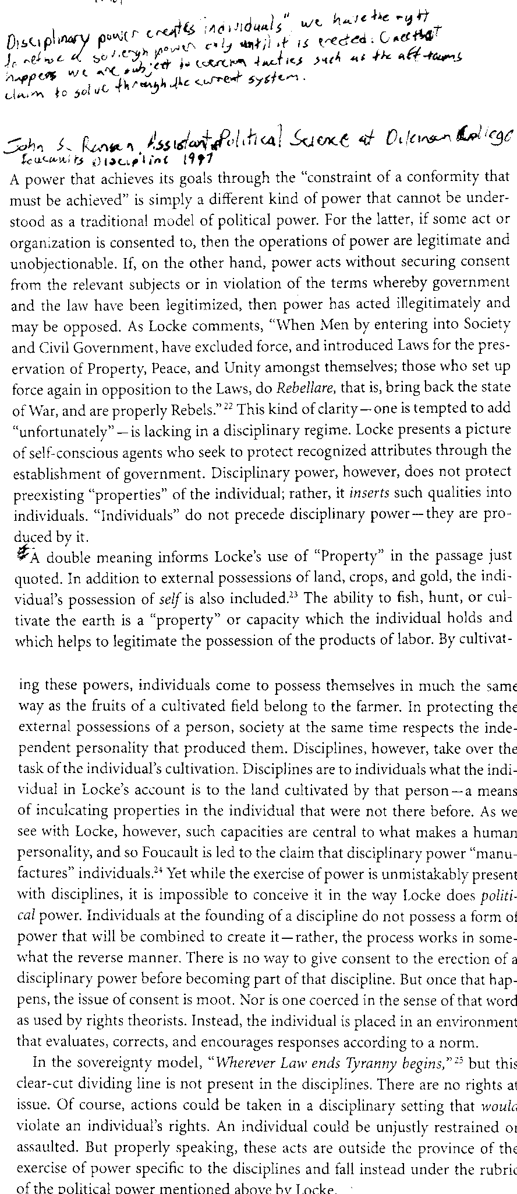

Interests Link
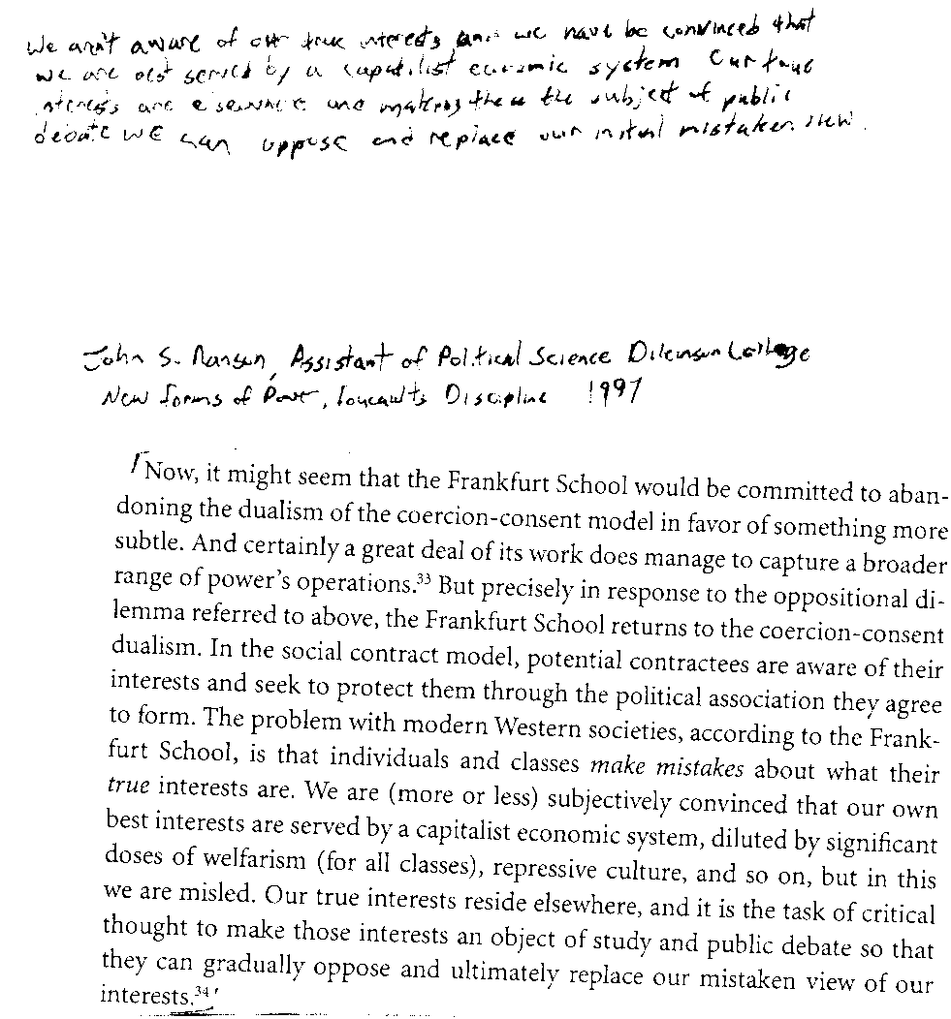

A2 : The State
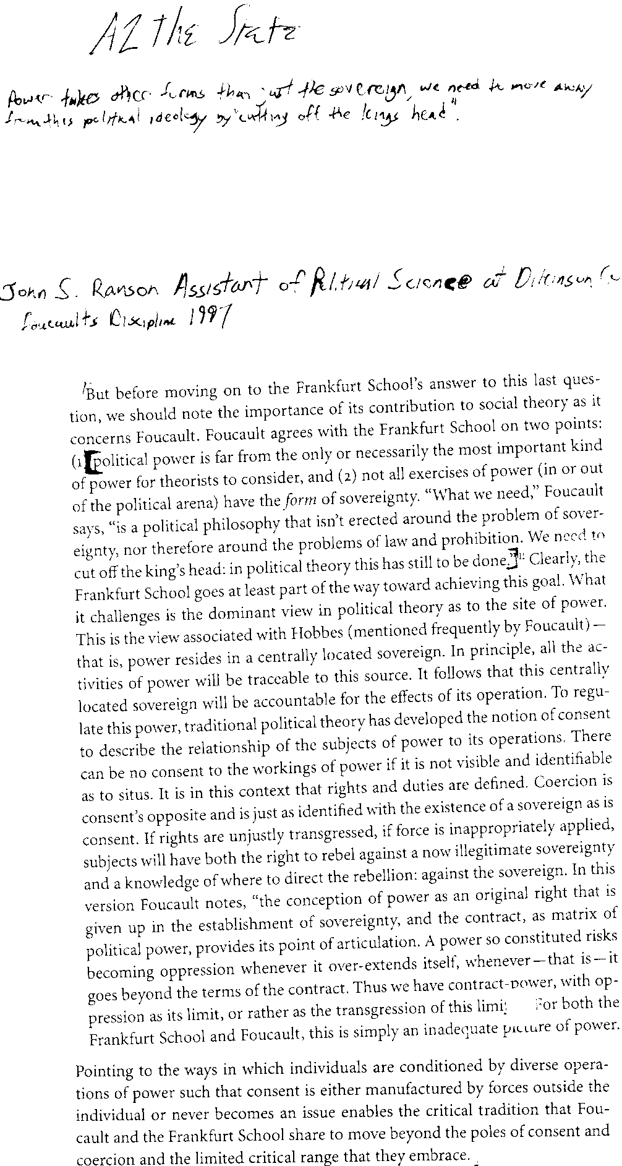

Impossible to Resist
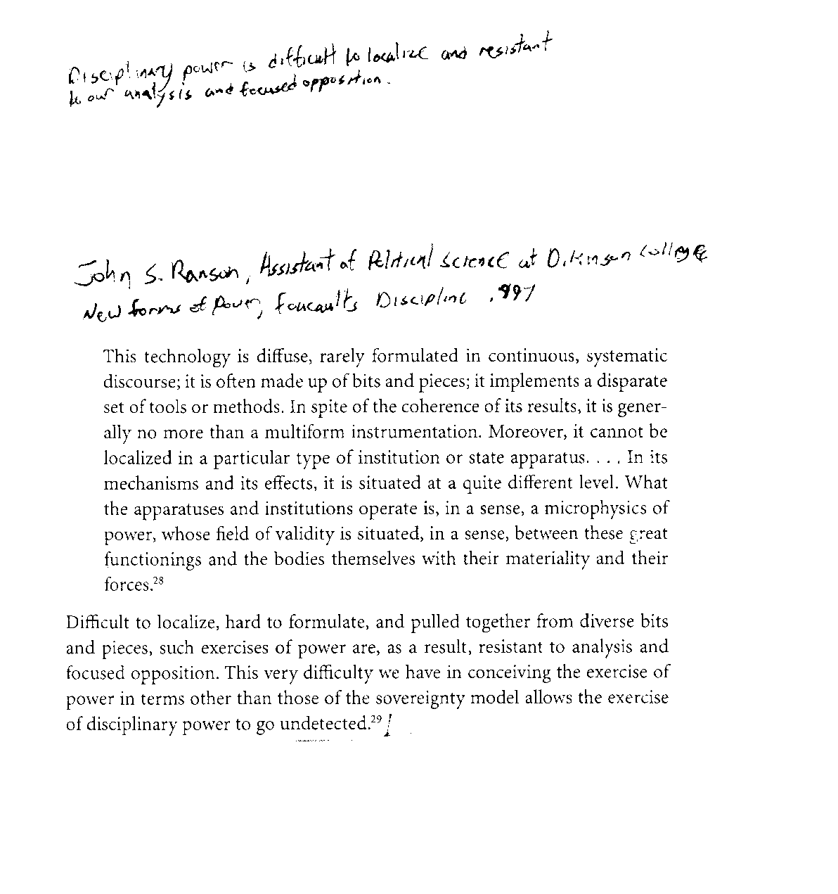

Impossible to Resist 